**AppEtizer**

DSN

Evan Stutevant, Kai McRoy, Emma Pinto, Jon Hopkins, and Jenna Waughen

CS 300 Software Engineering

Bill Thomas

2/22/2021

# Table of Contents

Executive Summary . . . . . . . . . . . . . . . . . . . . . . . . . . . . . . . . . . . . . . . . . . . . . . . . . . . . . . . . . . . . . 2

Team Introduction . . . . . . . . . . . . . . . . . . . . . . . . . . . . . . . . . . . . . . . . . . . . . . . . . . . . . . . . . . . . . . 3

Business Model . . . . . . . . . . . . . . . . . . . . . . . . . . . . . . . . . . . . . . . . . . . . . . . . . . . . . . . . . . . . . . . . . 4

Interview Results . . . . . . . . . . . . . . . . . . . . . . . . . . . . . . . . . . . . . . . . . . . . . . . . . . . . . . . . . . . . . . . . 5

Use Case Analysis . . . . . . . . . . . . . . . . . . . . . . . . . . . . . . . . . . . . . . . . . . . . . . . . . . . . . . . . . . . . . . . 6

Initial Requirements . . . . . . . . . . . . . . . . . . . . . . . . . . . . . . . . . . . . . . . . . . . . . . . . . . . . . . . . . . . . 9

Wireframe Models . . . . . . . . . . . . . . . . . . . . . . . . . . . . . . . . . . . . . . . . . . . . . . . . . . . . . . . . . . . . . . 10

Domain of the Application . . . . . . . . . . . . . . . . . . . . . . . . . . . . . . . . . . . . . . . . . . . . . . . . . . . . . .12

Glossary . . . . . . . . . . . . . . . . . . . . . . . . . . . . . . . . . . . . . . . . . . . . . . . . . . . . . . . . . . . . . . . . . . . . . . . .12

# Executive Summary

AppEtizer is a software product developed for Android devices, used for storing and maintaining user inputed recipes. It is designed for users to have a simple and central location for all of their recipes. AppEtizer will provide different avenues of customizing the order of recipes, through categories and sorting mechanisms, to make finding your favorite recipes all the more easily.

The user will have two different ways to input their recipe. One way of inputting is through scanning. This would just require a pdf file or a picture of the handwritten recipe where the app will scrape the text and input the information about the recipe. Another method of input is through a form on the app. It will ask the user about information on the recipe to which the user responds with filling out the form.

The app will have built in suggested categories such as meal type (breakfast, lunch, etc.) as well as type of dish (chicken, vegan, soup, etc.). The app will also have a feature that will allow users to enter their own categories so they will be able to sort and organize recipes to their own liking. There is no limit to how many category tags users are allowed to put on meals. Along with adding categories, users will also be able to delete categories they no longer use.

# Team Introduction

DSN is composed of 5 individuals: Evan Sturtevant, Kai McRoy, Emma Pinto, Jon Hopkins, and Jenna Waughen. All five members are Computer Science POEs at Juniata college currently enrolled in Software Engineering and Android Programming. During the 2021 Spring Semester the team will be working together to create the app AppEtizer. AppEtizer will be a recipe manager app designed for homecooks to easily store and organize all their recipes in one place. This will be the team’s first app.

# Business Model

This is the website where we got the template from: <https://www.aha.io/roadmapping/guide/templates/business-plan>

# Interview Results

11 potential users of AppEtizer were interviewed in order to determine desirable app functions. These users all cook at least once a week, most of whom use recipes often. The users were asked a series of questions including: how often they cook; how often they use recipes; where they keep their recipes, generally; and what features they would like to see in a recipe manager app.

Many of these potential users tended to store their recipes either in a recipe box, on paper, or online.

Some common feature recommendations include: Categorizing recipes, both with suggested categories and an ability to insert custom ones; the ability to favorite recipes; the ability to sort recipes by frequency of use; the ability to search for recipes by ingredients or by category; the ability to scan in recipes from pdf, or handwritten formants.

# Use Case Analysis

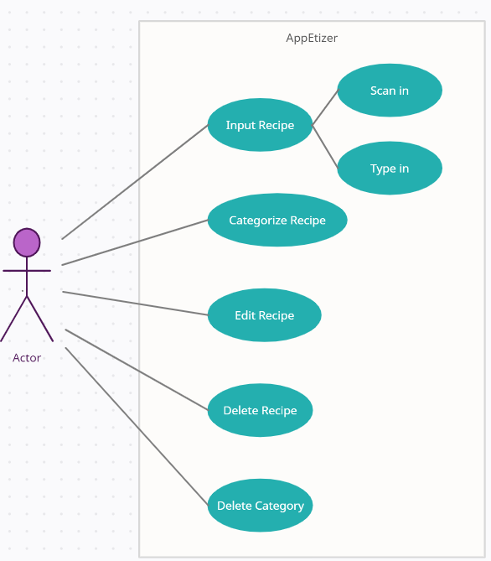

|  |
| --- |
| **Brief Description**  The *Input Recipe* use case enables the user to input a recipe into AppEtizer by either *Scan In* or *Type In* their desired recipe. |
| **Step-by-Step Description**   1. User inputs recipe via scanning or manually typing and determines category/categories to put the recipe in. 2. Recipe is entered into the recipe database with category tags. |

|  |
| --- |
| **Brief Description**  The *Categorize Recipe* use case enables the user to create categories to organize recipes. |
| **Step-by-Step Description**   1. User inputs a new category. 2. New category gets added to the recipe database. |

|  |
| --- |
| **Brief Description**  The *Edit Recipe* use case enables the user to modify a recipe that has been previously entered. |
| **Step-by-Step Description**   1. User designates a desire to modify a recipe. 2. The old version of the recipe is retrieved from the recipe database. 3. User modifies recipe. 4. The modified version of the recipe is stored back in the recipe database. |

|  |
| --- |
| **Brief Description**  The *Delete Recipe* use case enables the user to delete recipes. |
| **Step-by-Step Description**   1. User designates a desire to delete a recipe. 2. The old version of the recipe is retrieved from the recipe database. 3. User deletes recipe. |

|  |
| --- |
| **Brief Description**  The *Delete Category* use case enables the user to delete categories. |
| **Step-by-Step Description**   1. User designates a desire to delete a category. 2. The old category is retrieved from the recipe database. 3. User deletes category. |

# Initial Requirements

|  |
| --- |
| Functional Requirements |
| The user can interact with the app in a multitude of different ways. The main aspect of the software is to store recipes for the user to refer to when cooking or baking. This means one of the functional requirements is the user must be able to input recipes. This can be done through a form on the app or through scanning. The user must be able to sort these recipes by categories. The recipe list will then have recipes in said categories at the top, easier to select for the user. These categories can be automatically generated using data from the recipes or as well as being created by the user. Users can create and delete categories at will. |

|  |
| --- |
| Non-Functional Requirements |
| The software product will run on Android. It will be developed using Android Studio. The lowest API that our software product will run on is API 21: Android 5.0 (Lollipop). The software product will be stable enough to run 99% of the time. Fine-tuning and optimizing the software product is very important for our team. Therefore, we are committed to having recipe queries take up to two seconds. This also applies to sorting the categories as well, sorting initiated by the user will only take up to five seconds. Pulling up the app from a suspended state will continue the app; keeping it on the last selected recipe. |

# Wireframe Models

The wireframe above is an idea of what the main screen will look like in AppEtizer. It shows recipes. The button in the lower right hand corner allows the user to input a recipe.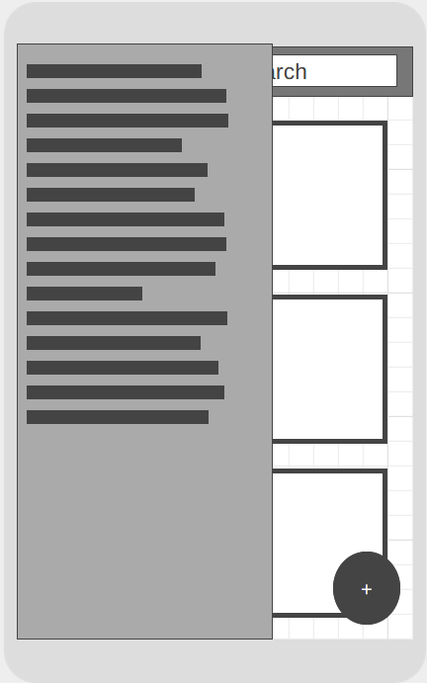

The second wireframe is what the menu will potentially look like. It will come out from the side allowing the user to go back and forth from recipes categories, the home page, or scanning in a recipe.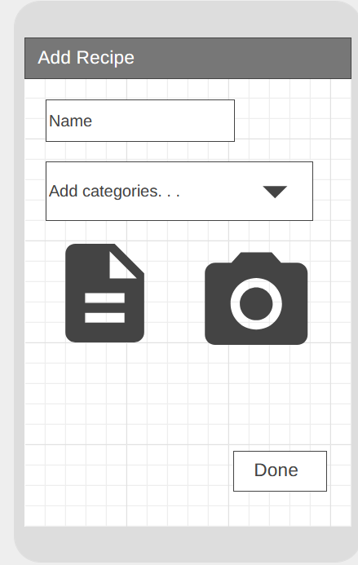

The final wireframe is the page allowing the user to scan or inout their recipes by naming them, adding them to a category, then adding the recipe, and then potentially adding a picture if the user chooses to.

# Domain of the Application

The domain of the application is the culinary world specifically for home cooking. The app is intended for users who regularly cook from home that use a variety of recipes from multiple sources. The purpose of the app is to collect and organize the user’s recipes.

# Glossary

**Cook time:** The time it takes to cook a specific dish.

**Directions:** The steps necessary to prepare the ingredients into the dish.

**Ingredients:** The individual food items needed to make a specific dish.

**Nutrition facts:** Are the data used to explain the health benefits of each meal.

**Prep time:** The time it takes to prepare the food before cooking.

**Recipe:** List of instructions that explain how to prepare a specific dish.

**Servings:** The amount of people a recipe will serve based on the amount of ingredients.

**Total time:** The total time it takes to make the meal.